Check if Git is installed
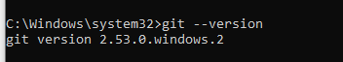
This means git is installed and we can continue
Create First Project Folder
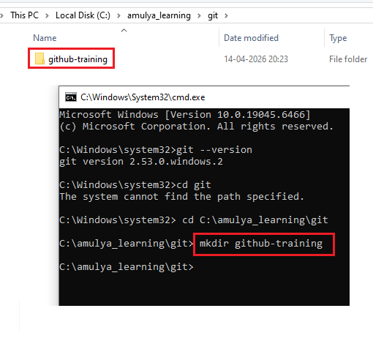Initialize Git repository
git init
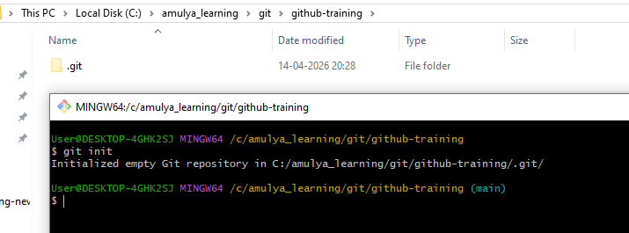
It is a command that initializes a new Git repository in your current folder. It creates a hidden .git directory, which contains all the internal data Git needs to track your project.
You cannot use:
- git add
- git commit
- git branch
- git push
unless git init (or git clone) is done first
Create First File
echo “This is my first file” > firstfile.txt
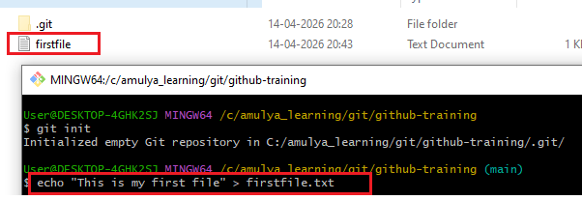
Track File
git add firstfile.txt
file will move to staging phase and git will start tracking this file
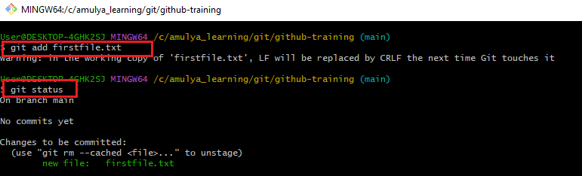
You can check the status of this file by using command “git status” if the file is tracking it will show in green color and any modification done and not tracked yet, it will show in red
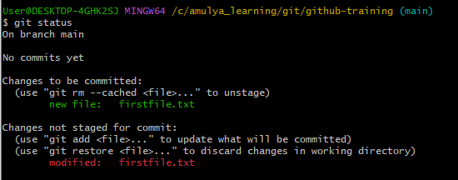
Save Version (Commit)
Once you are ready with your file and want to move to local repo you have to commit the file
git commit –m “message for commit”
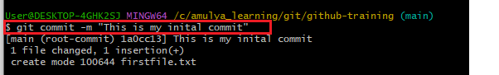
After commit you can check the status using command “git log”
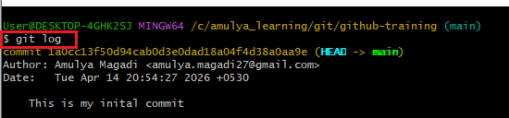
This will give info like commit ID, author, timestamp and comment
If you want this info in one line then you can use command like
git log –oneline
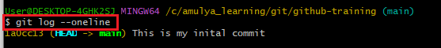
Create a Learning Repository in GitHub
Name: aws-devops-learning-log
Clone
Cloning means creating a full local copy of a remote repository (usually from GitHub) onto your machine.
